**Assignment MT1-2019-3**

**Section 1**

* 1. Develop an expression for

1. Drying time in the case of drying of a Spherical water droplet
2. Sublimation time of a Cylindrical naphthalene rod
3. Molar transfer rate from a tank 1 to tank 2 connected through a tapered tube

1.2. Describe experimental method for measuring the binary gas phase diffusivity using Stefan tube/Arnold diffusion cell

1.3 Describe experimental method for measuring the binary gas phase diffusivity using twin bulb

1.3. Describe experimental methods for measuring the binary liquid phase diffusivity using diaphragm cell

**Section 2**

Ex.2.18 Page no.56

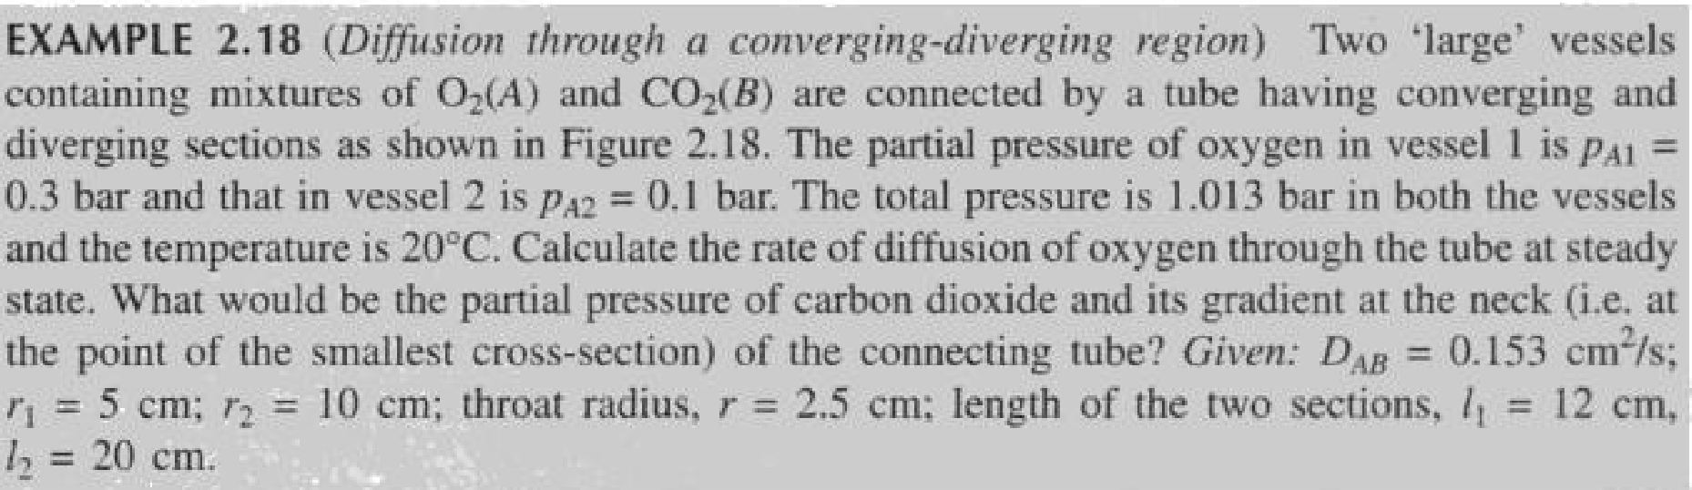

Ex.2.17 Page no.55

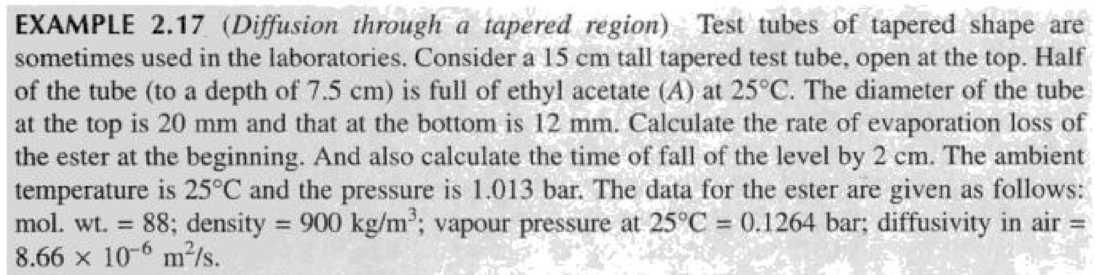

**Ex.2.14 page no.51**

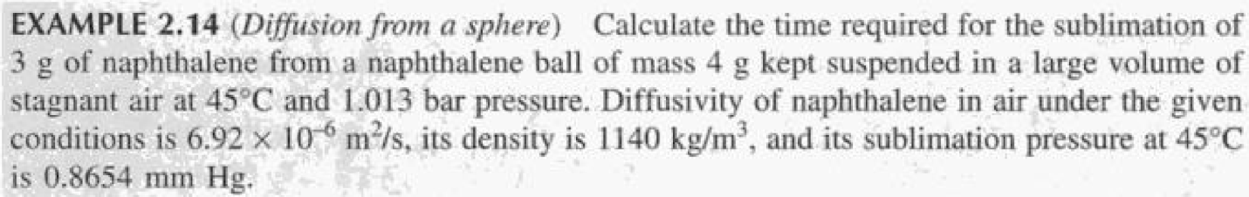

**Ex.2.15 Page no.51**

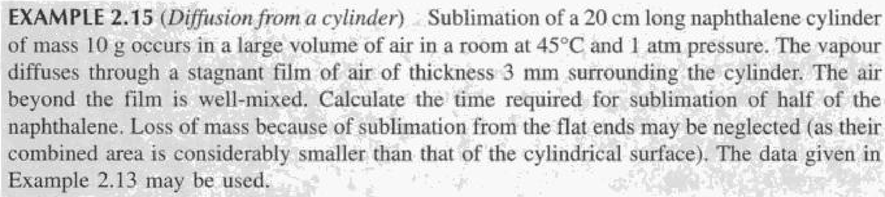

**Section 3**

**3.1)** A sphere of naphthalene having a radius of 2mm is suspended in a large volume of shell air at 318 K and 1 atm. The surface pressure of the naphthalene can be assumed to be at 318 K is 0.555 mm Hg. The D AB of naphthalene in air at 318 K is 6.92 * 10 –6m 2/sec. Calculate the rate of evaporation of naphthalene from the surface.

**3.2)** A 20-cm-long, cylindrical graphite (pure carbon) rod is inserted into an oxidizing atmosphere at 1145 K and 1.013*105 Pa pressure. The oxidizing process is limited by the diffusion of oxygen counter flow to the carbon monoxide that is formed on the cylindrical surface. Under the conditions of the combustion process, the diffusivity of oxygen in the gas mixture may be assumed to be 1.0* 10-5 m2/s.

* + Determine the moles of CO that are produced at the surface of the rod per second at the time when the diameter of the rod is 1.0 cm and the oxygen concentration that is 1.0 cm radial distance from the rod is 40 mol%. Assume a steady state process.
  + What would be the composition of oxygen 1.0 cm from the center of the rod.

**3.3)**Ethanol is diffusing through a 4-mm stagnant film of water. The ethanol concentrations of the entrance and the existing planes are maintained at 0.1 and 0.02mol/m3 respectively. If the water film temperature is 283 K, determine the steady-state molar flux of the ethanol and the concentration profile as a function of the position z within the liquid film. Compare these results with a 4-mm stagnant film of air at 283 K and 1 atm at the same entrance and exit ethanol concentrations.

**3.4)**